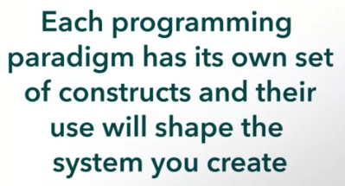



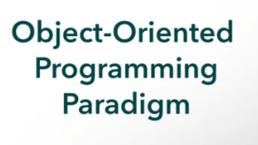

OOP Principles

1. Abstraction
2. Encapsulation
3. Decomposition
4. Generalization

OOP Design Patterns

1. Creational
2. Structural
3. Behavioral

**OBJECT-ORIENTED ARCHITECTURAL STYLE**





Example: Automatic Pet Feeder

Objects:

1. Pets
   1. Attributes
      1. Collar ID
      2. Maximum daily food intake amount
      3. Current food intake amount
2. Food dispenser
   1. Attributes
      1. Which pets are authorized to visit it?
      2. How much food is left?